1
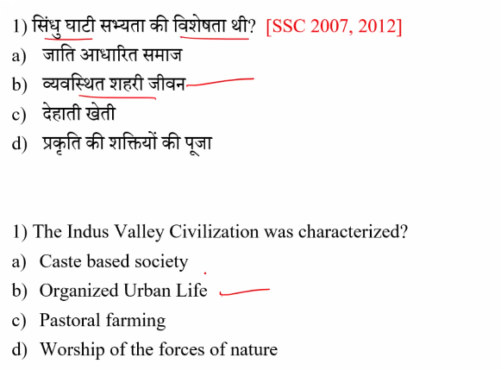
2

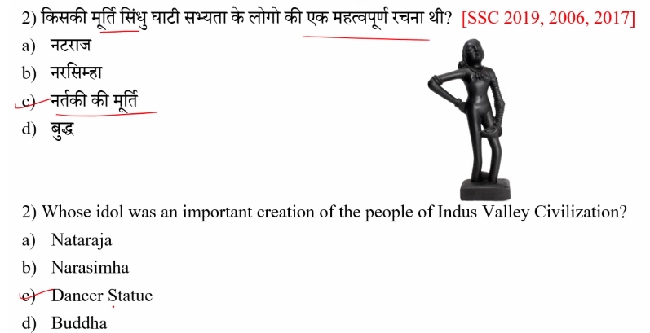

3
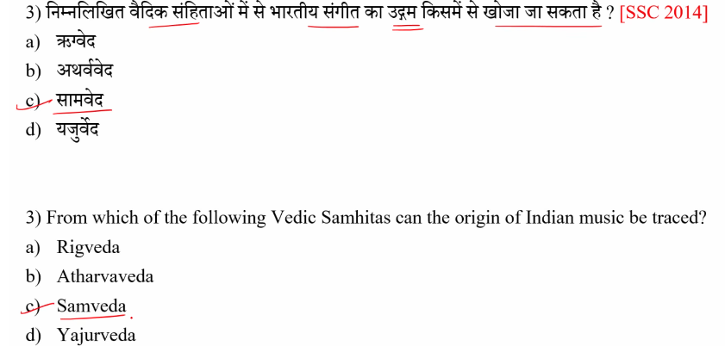

4
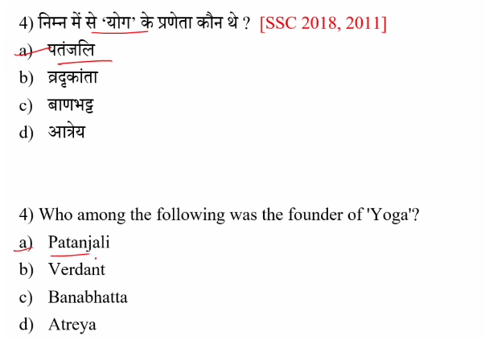

5

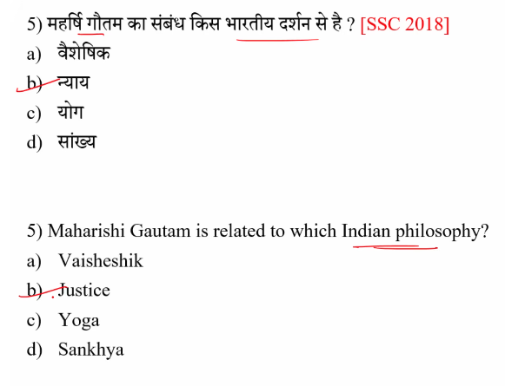
6
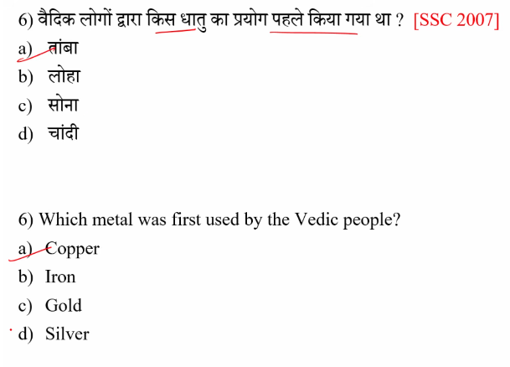

7 Copper + Tin= Bronze
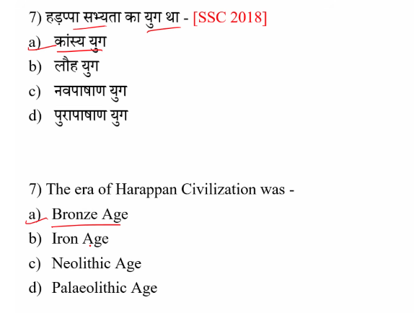
8
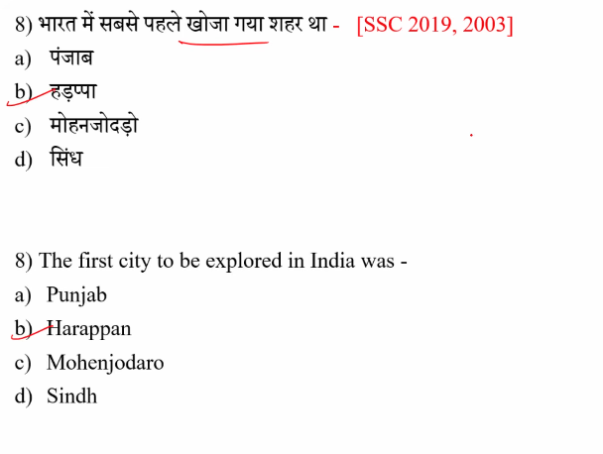
9
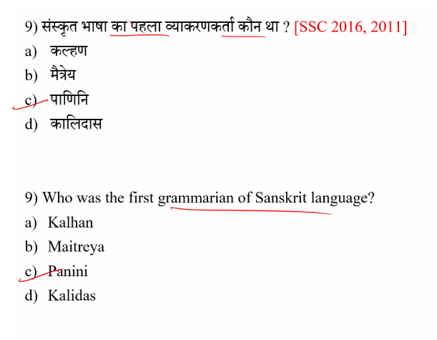’
10
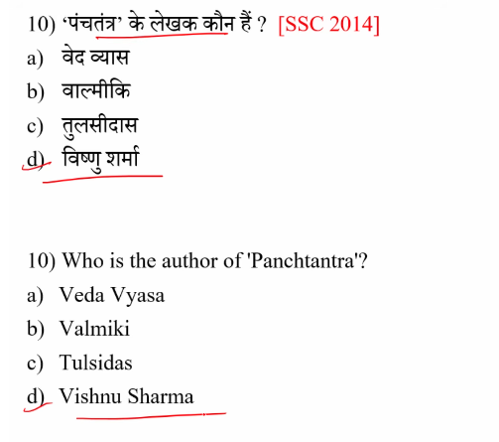
11
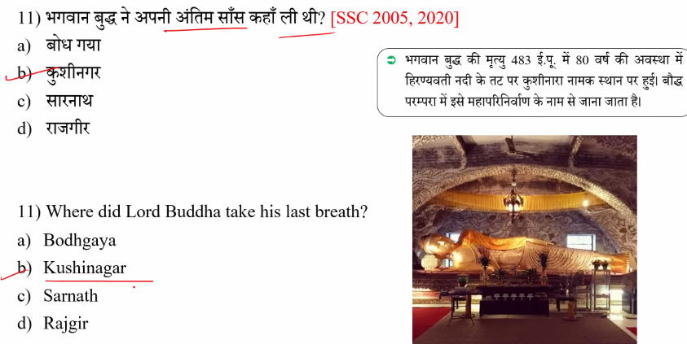

12
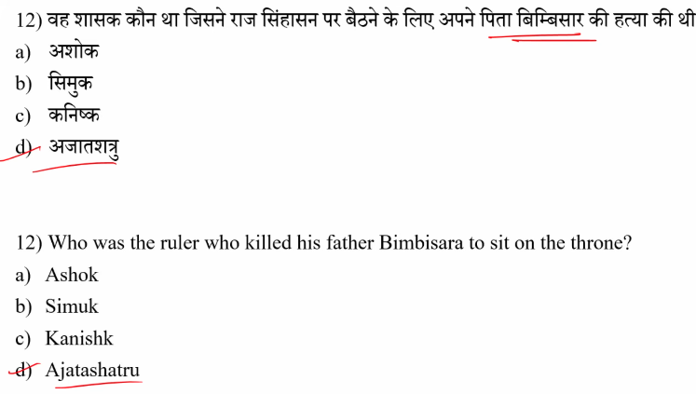’
13
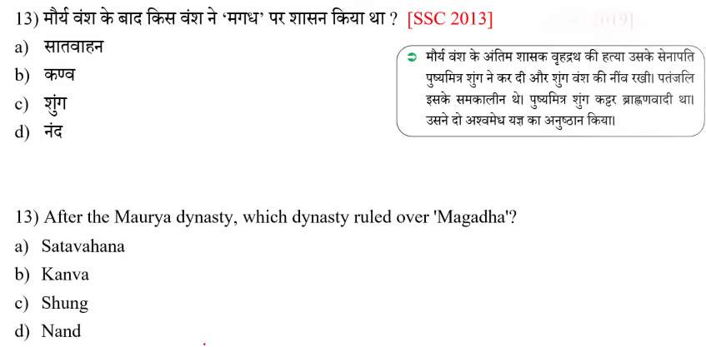

14
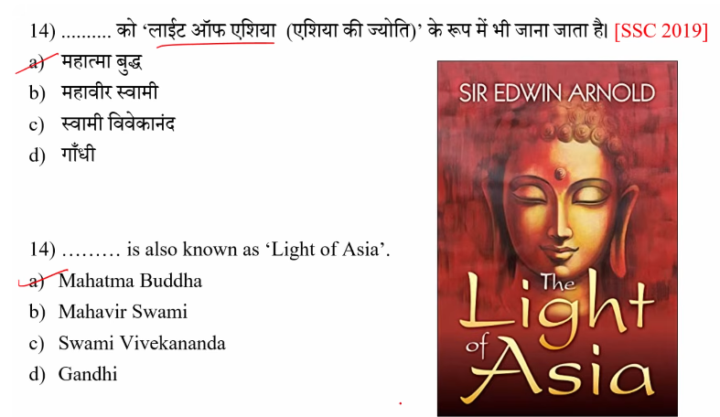

15
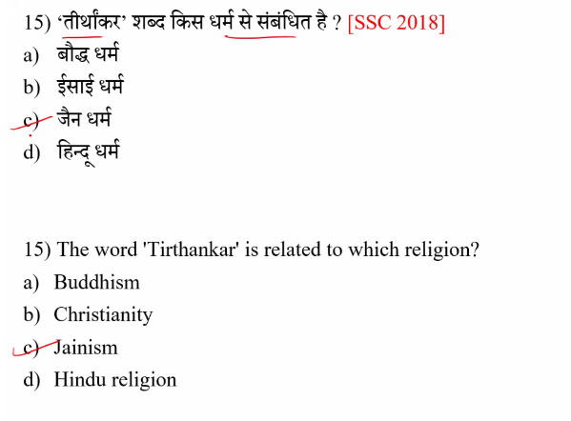

16

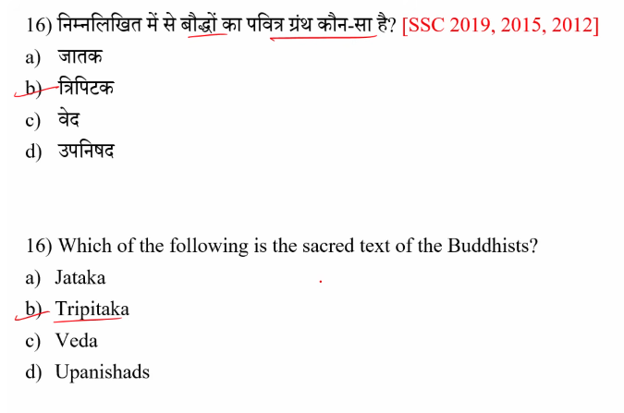
17
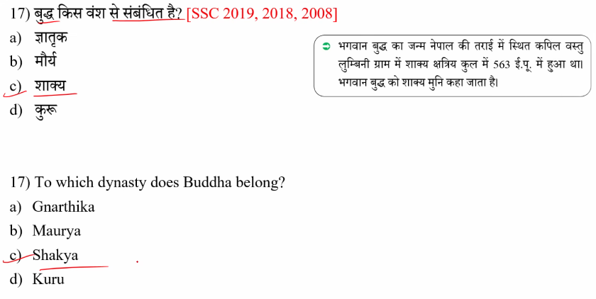

18
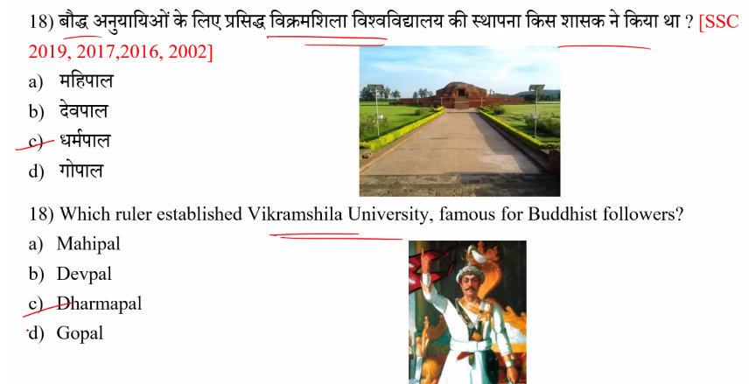
Vikramashila University was founded by King Dharmapala of the Pala Dynasty in the late 8th or early 9th century CE. Located in present-day Bhagalpur, Bihar, it was a premier center for Buddhist learning, particularly in Tantric studies, and thrived for four centuries before its destruction in the 12th century.
Key Details About the Founder and Institution:
- Founder: King Dharmapala, the second ruler of the Pala Dynasty, established the university to promote Buddhist studies.
- Location: Situated on a hilltop along the Ganges in Antichak village, Bhagalpur district, Bihar.
- Significance:
It was one of the three major Mahaviharas (universities) of the Pala era, alongside Nalanda and Odantapuri.
- Specialization: It was particularly renowned for Tantric Buddhism (Vajrayana).
- Destruction: The university was destroyed by Bakhtiyar Khilji around the end of the 12th century.
The ruins of the university today are a significant archaeological site.

19
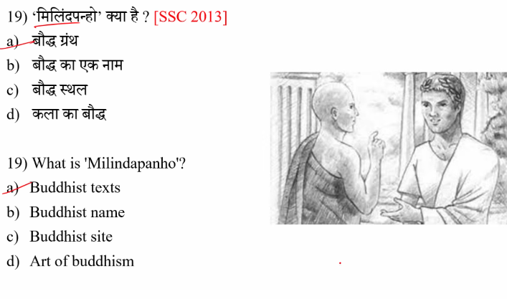

20
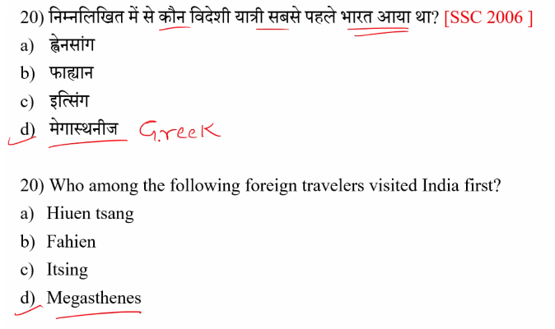
Celusus neckater ka rajdoot at chandrgutpat Mauryan

21
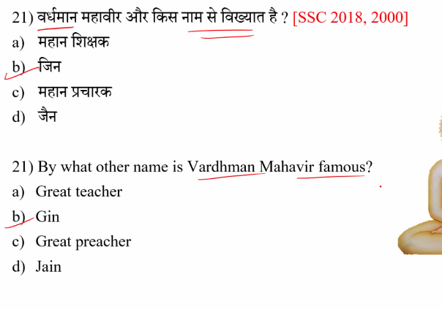

22
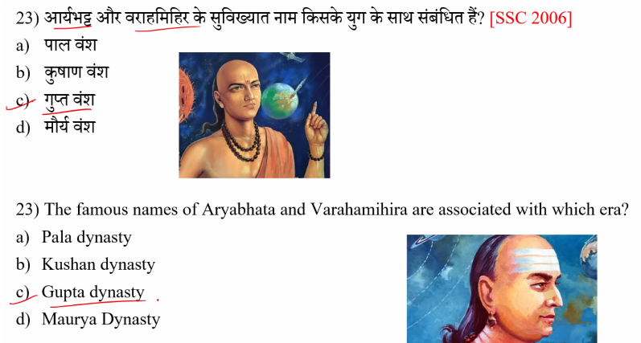

23

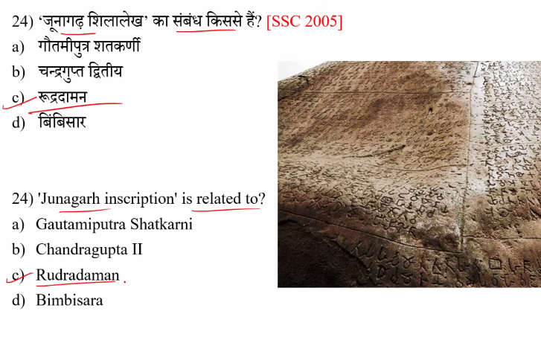

24
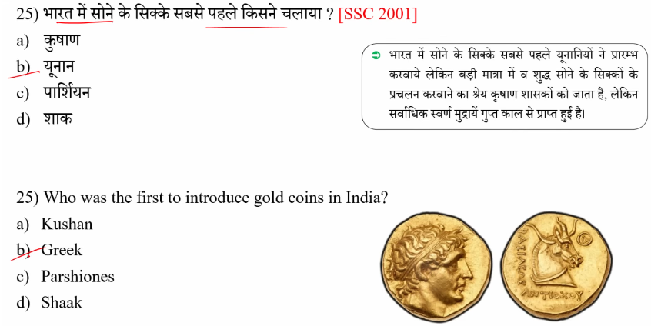
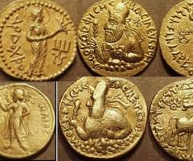
The Indo-Greeks were the first rulers in India to issue gold coins that can be definitively attributed to specific kings, often featuring high purity and Greek artistic styles. While the Kushanas (specifically Vima Kadphises) are widely recognized for introducing gold coins on a large, standardized scale, the earliest definitive gold coinage is traced back to the Indo-Greek era.
- Indo-Greeks (2nd Century BCE): Introduced Greek-influenced die-struck gold coins.
- Kushana Dynasty (1st Century CE): Vima Kadphises issued gold coins of high purity, often derived from Roman gold trading.

25
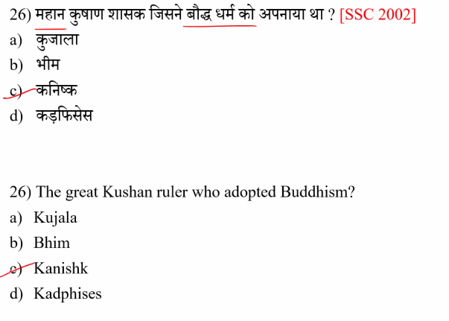

26
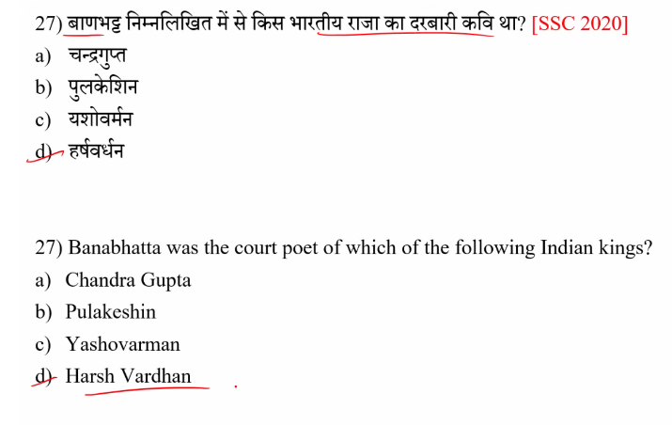

27
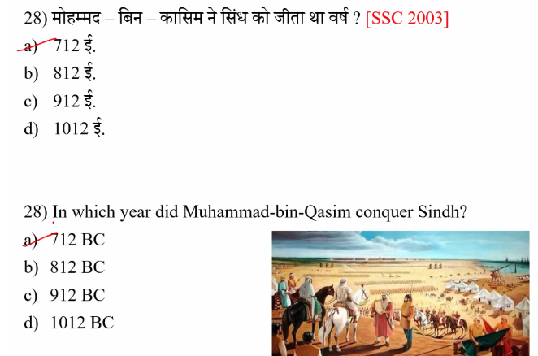

28
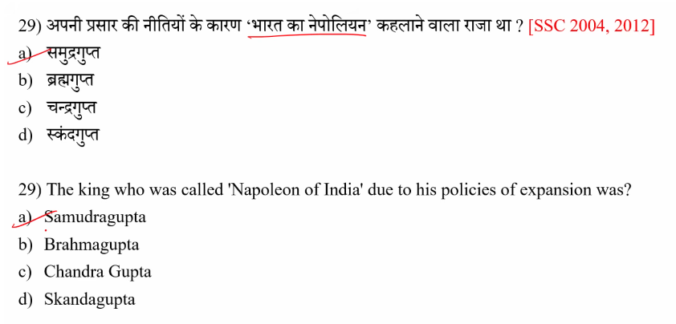

29
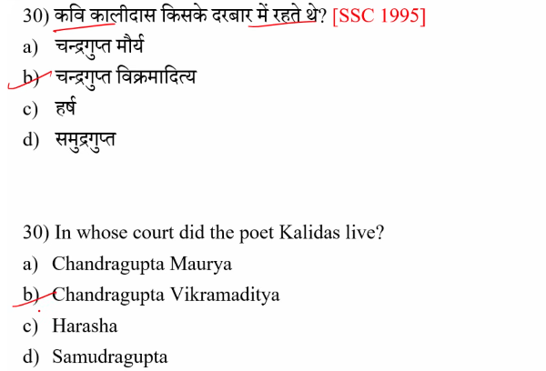

30
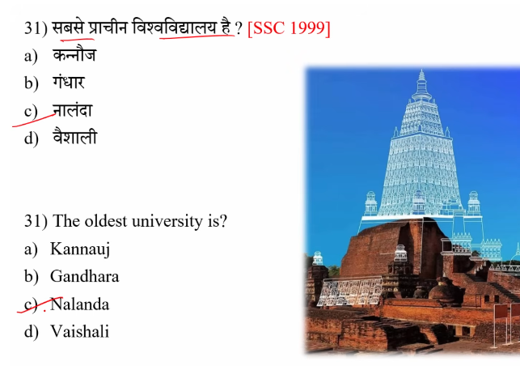
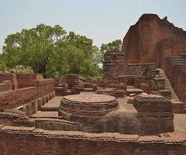
Takshashila (Taxila), operating from around 600–700 BCE in ancient Gandhara (modern-day Pakistan), is widely recognized as the oldest university in ancient India and one of the earliest in the world. Known for studies in medicine, law, and military science, it pre-dated other famous centers like Nalanda.
Key Ancient Indian Universities:
- Takshashila (Taxila): Established ~7th-6th Century BCE, it was a premier center for Vedic studies, Ayurveda, and politics.
- Nalanda: Founded in the 5th century CE in Bihar, it was a major Buddhist center, often regarded as the first residential university.
- Vikramashila
:
Founded by King Dharmapala in the 8th century CE, specializing in Buddhist Tantric teachings.
- Valabhi: A major center for learning in Gujarat (6th-12th century CE) specializing in Buddhist and Jain philosophy.

31
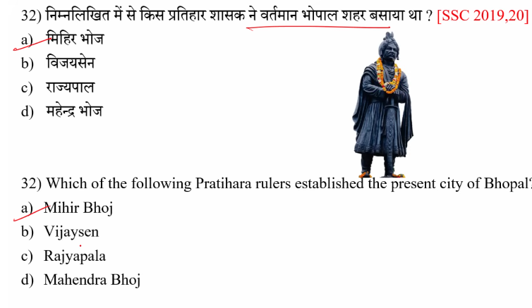

32

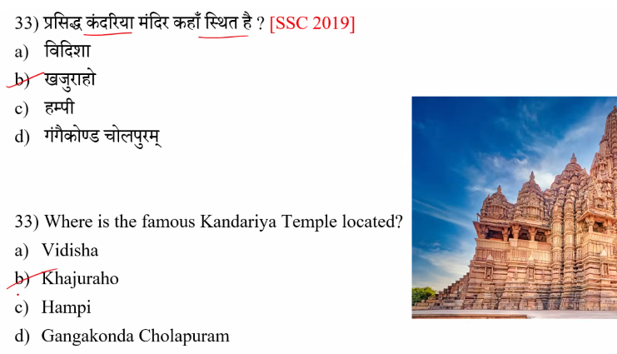

33
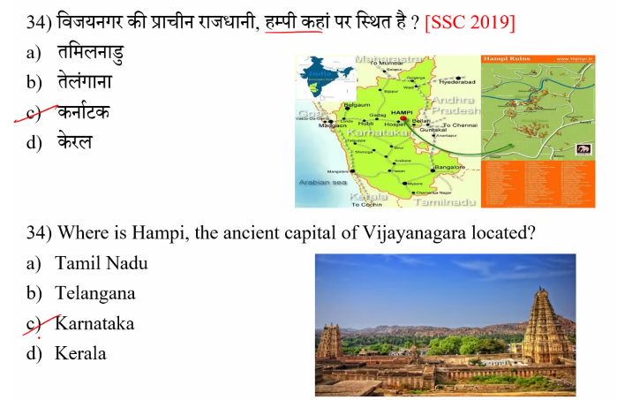
34
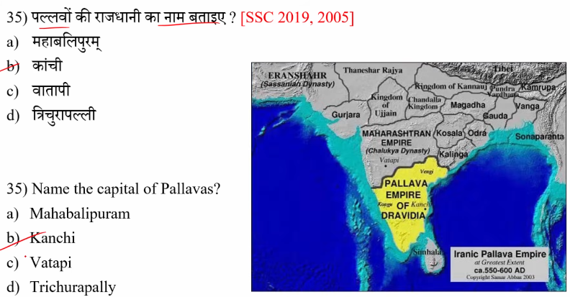

35
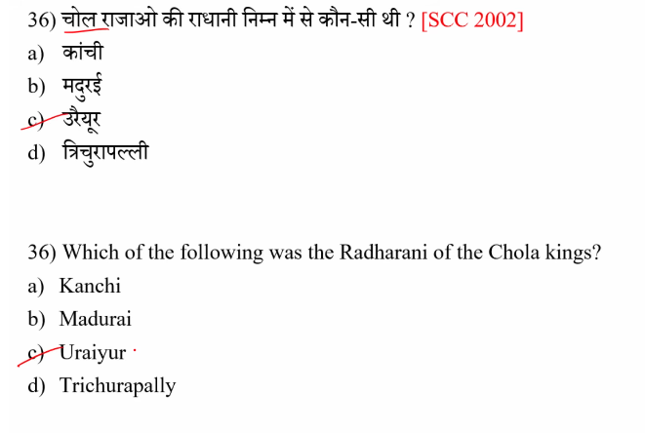

36
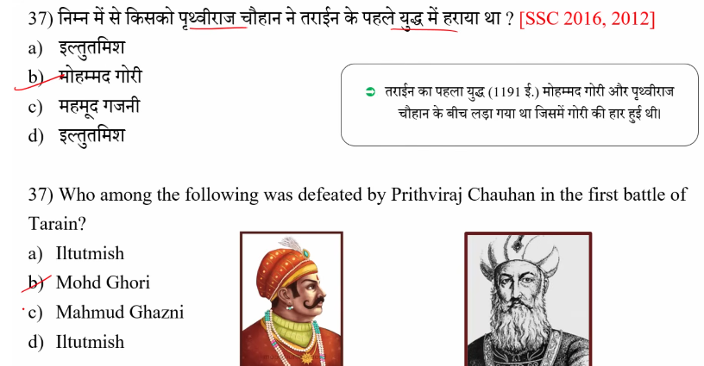

तराइन के युद्ध (Battles of Tarain) भारत के मध्यकालीन इतिहास के दो महत्वपूर्ण युद्ध थे, जो 1191 और 1192 ई. में लड़े गए थे।
⚔️ पहला तराइन का युद्ध (1191)
- लड़ा गया: पृथ्वीराज चौहान बनाम मुहम्मद गौरी
- स्थान: तराइन (आज का तरावड़ी, हरियाणा)
- परिणाम: पृथ्वीराज चौहान की जीत
- खास बात: गौरी को हारकर भागना पड़ा
⚔️ दूसरा तराइन का युद्ध (1192)
- फिर से वही शासक आमने-सामने आए
- परिणाम: मुहम्मद गौरी की जीत
- खास बात: इस बार गौरी ने बेहतर रणनीति अपनाई और पृथ्वीराज चौहान को हरा दिया
📌 महत्व
- दूसरे युद्ध के बाद भारत में मुस्लिम शासन की नींव पड़ी
- इससे दिल्ली सल्तनत की स्थापना का रास्ता साफ हुआ
- यह युद्ध भारतीय इतिहास का टर्निंग पॉइंट माना जाता है
अगर चाहो तो मैं इसे और आसान नोट्स या शॉर्ट ट्रिक में भी समझा सकता हूँ 👍

37

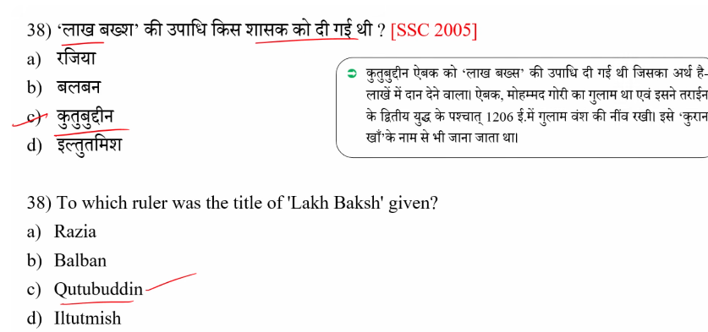

38
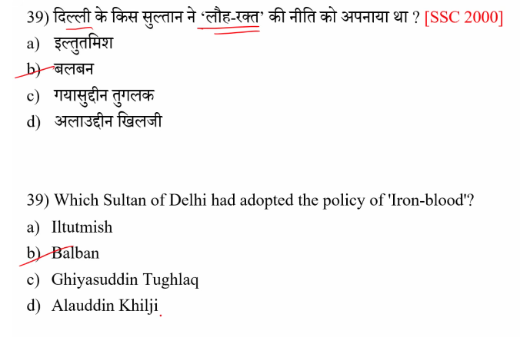
39
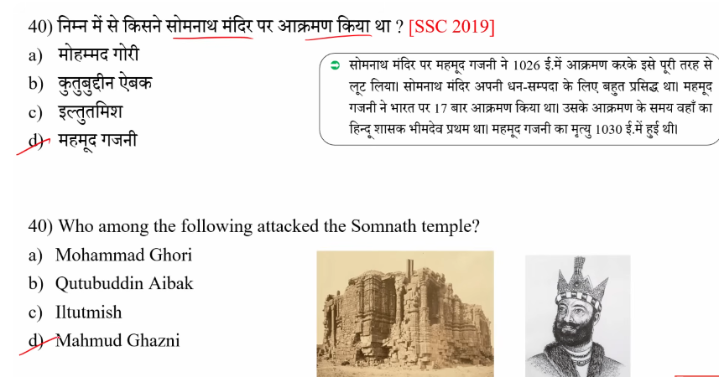

40
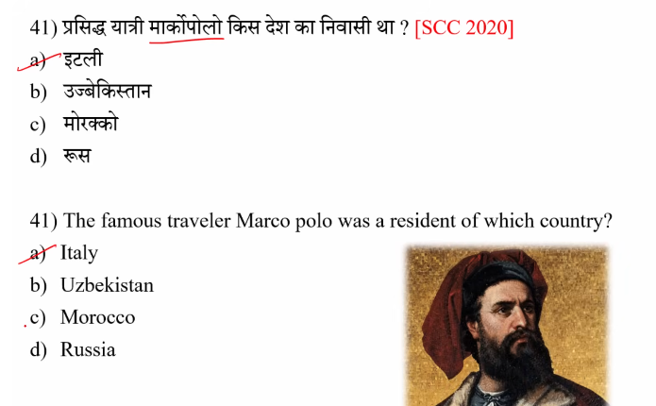
Marco Polo (1254–1324) was an Italian merchant, explorer, and writer born in the Republic of Venice. While he spent roughly 17 years traveling through and working in Asia, specifically in China under Mongol emperor Kublai Khan, his nationality and citizenship were Venetian.
Key Details About Marco Polo's Origins:
- Birthplace: Venice, Italy (then the Republic of Venice).
- Career: He was a traveler and merchant who documented his journeys along the Silk Road in his famous book, Travels of Marco Polo.
- Later Life: He lived and died in Venice, where he was nicknamed Il Milione.

41
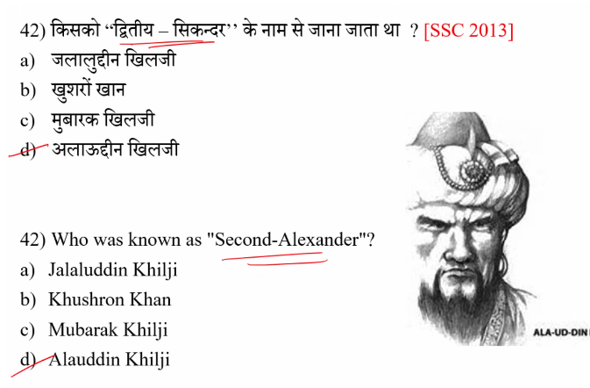

Bharat ka nepolian – Samudragupta

42
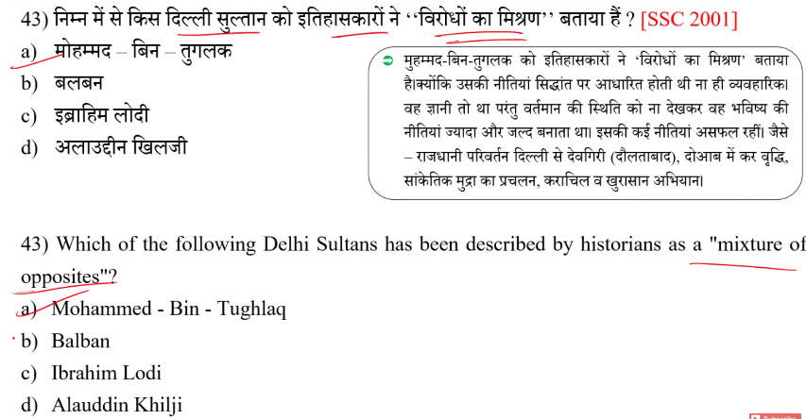

43
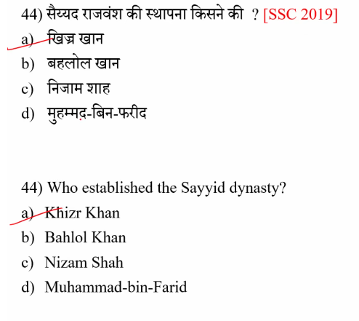
44
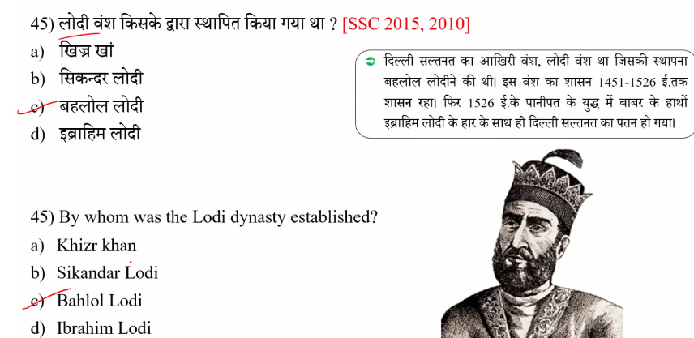

45
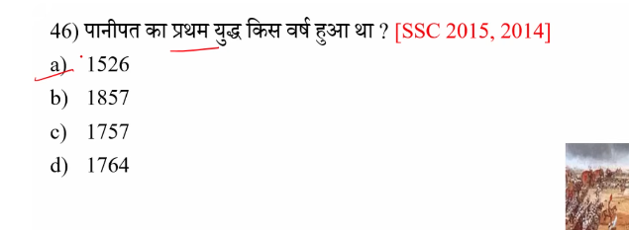

Panipat ke Yudh Bharat ke itihaas ke teen bahut mahatvapurn yudh the jo Panipat mein lade gaye. Inhone desh ki rajneeti aur shakti santulan ko badal diya.

⚔️ 1. Pehla Panipat ka Yudh (1526)
- Kiske beech: Babur vs Ibrahim Lodi
- Parinam: Babur ki jeet
- Mahatva:
  - Bharat mein Mughal Samrajya ki sthapna hui
  - Top (gunpowder artillery) ka pehli baar bada upyog hua

⚔️ 2. Doosra Panipat ka Yudh (1556)
- Kiske beech: Akbar (Bairam Khan ke saath) vs Hemu
- Parinam: Akbar ki jeet
- Mahatva:
  - Mughal shasan fir se majboot hua
  - Akbar ka rajya sthir hua

⚔️ 3. Teesra Panipat ka Yudh (1761)
- Kiske beech: Ahmad Shah Abdali vs Maratha Empire
- Parinam: Abdali ki jeet
- Mahatva:
  - Maratha shakti ko bhari nuksaan
  - Bharat mein British ke badhte prabhav ka raasta saaf hua

46

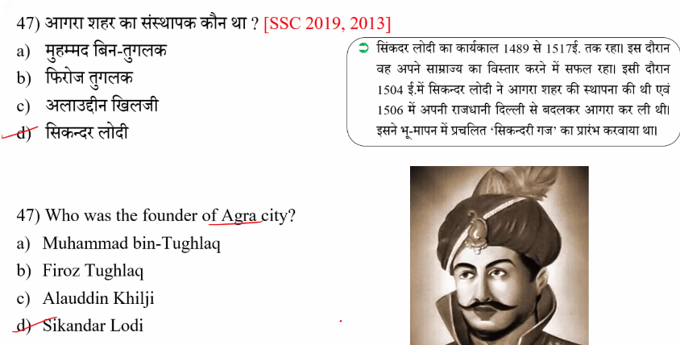

47
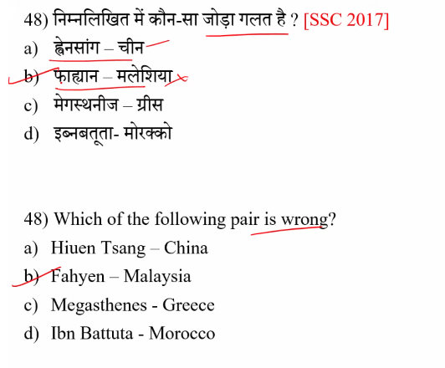
48

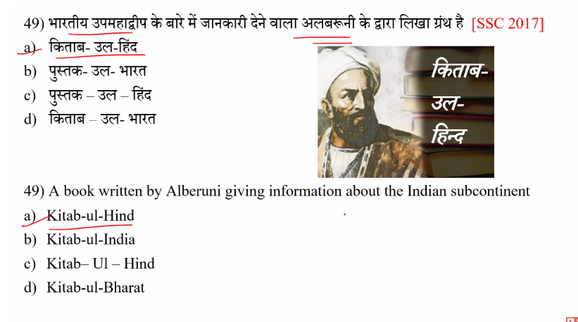

49
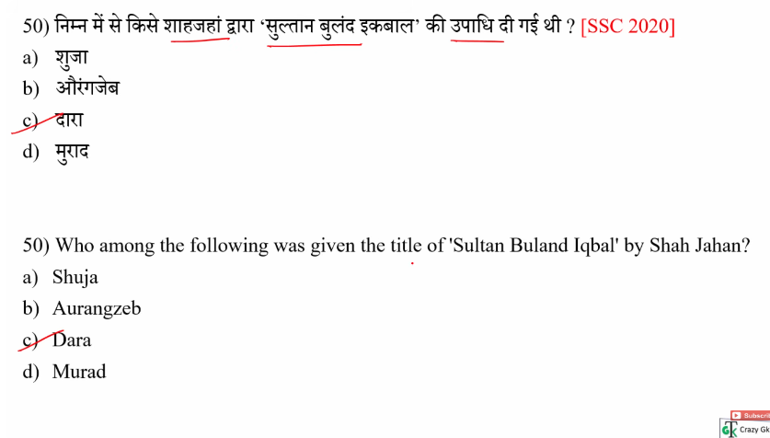

50
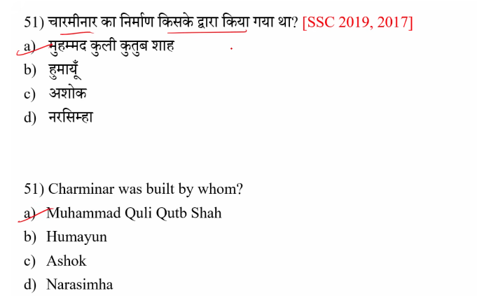

“Outrageous”
👉 “Bahut hi galat / had se zyada / asahniya / sharmnaak”
- Jab koi baat ya kaam itna extreme ho ki log gussa ya shock ho jayein, use outrageous kehte hain.
🔹 Examples:
- His behavior was outrageous.
→ Uska vyavhaar bahut hi galat / sharmnaak tha.
- The price is outrageous!
→ Yeh daam had se zyada hai!

??51
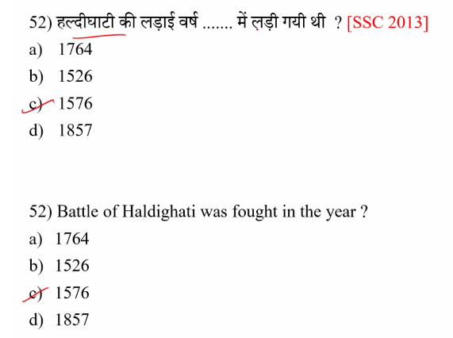

52
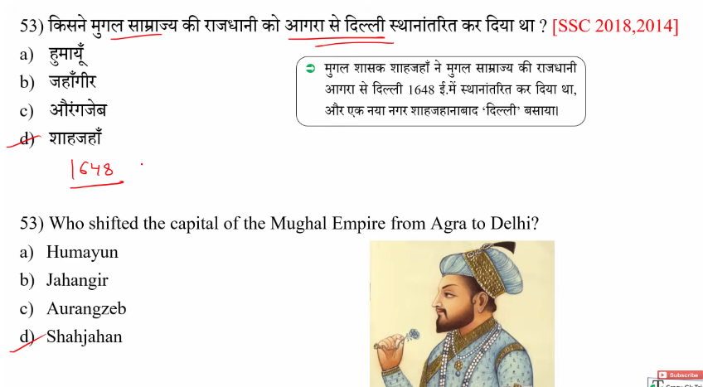
53

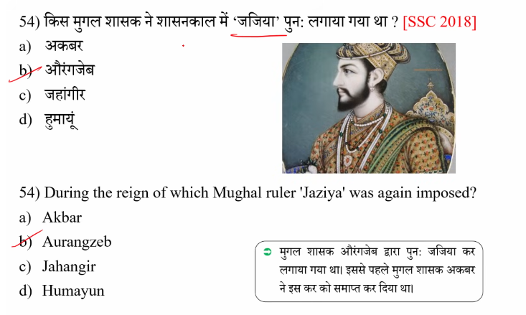

54

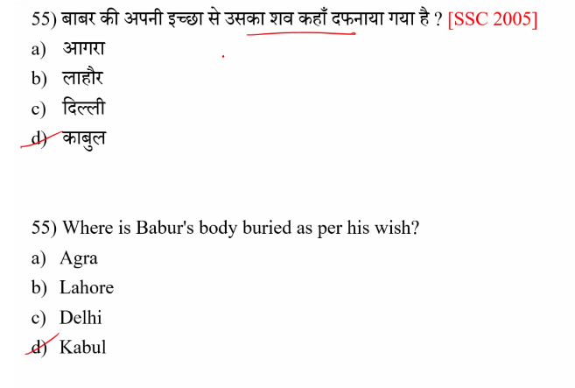

55
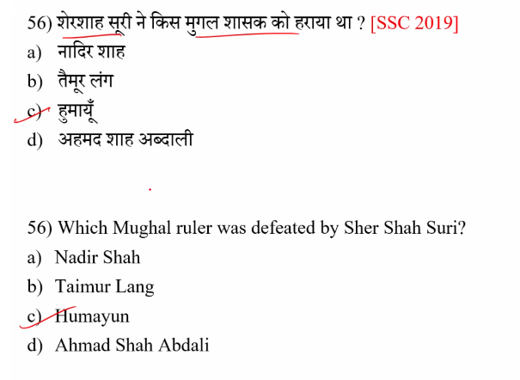

56

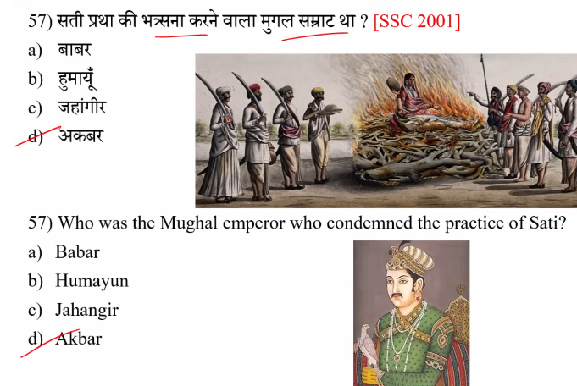

57
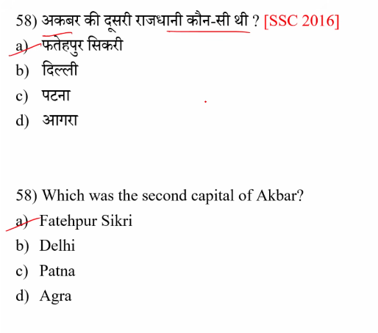

58
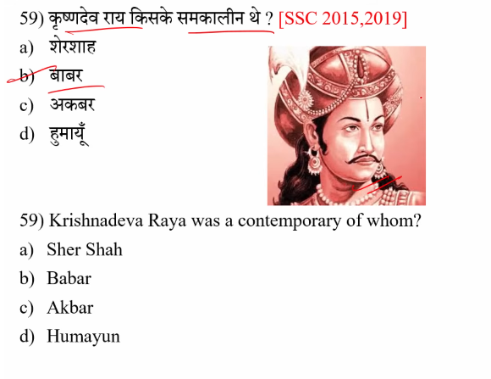
59

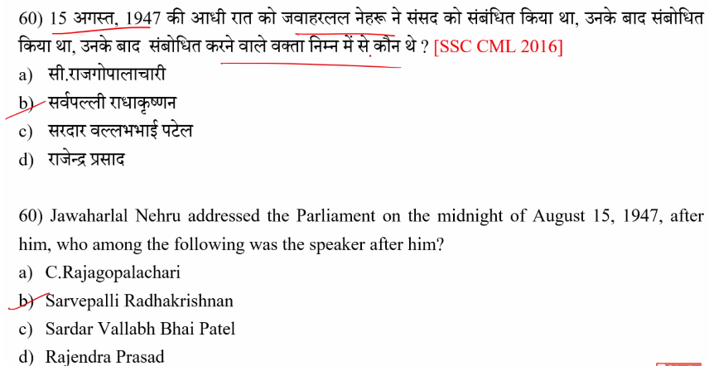

60
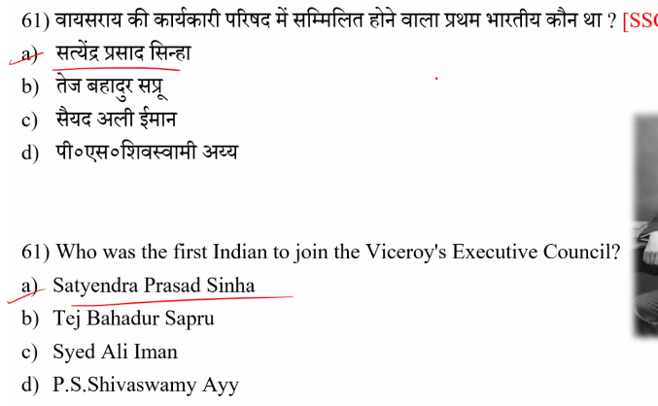

61

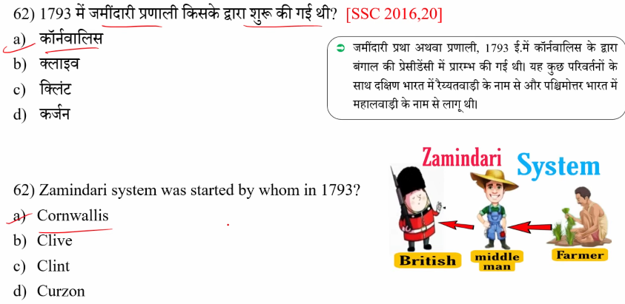

62

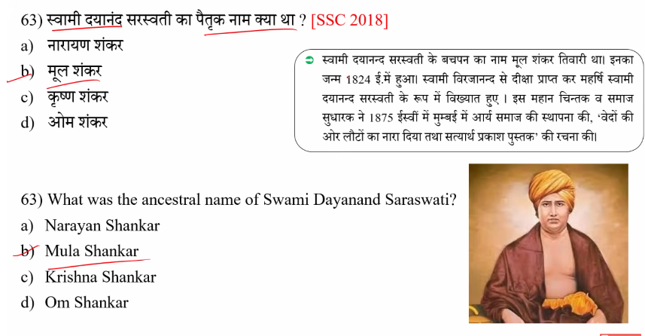

63
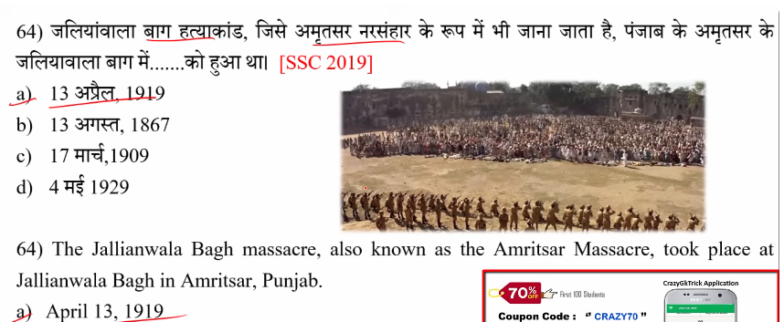

64

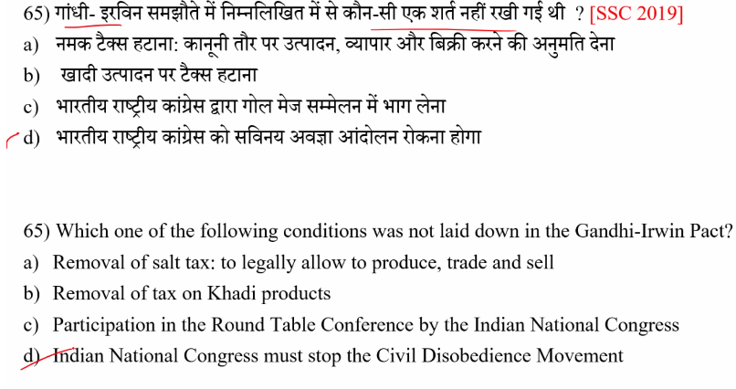

65
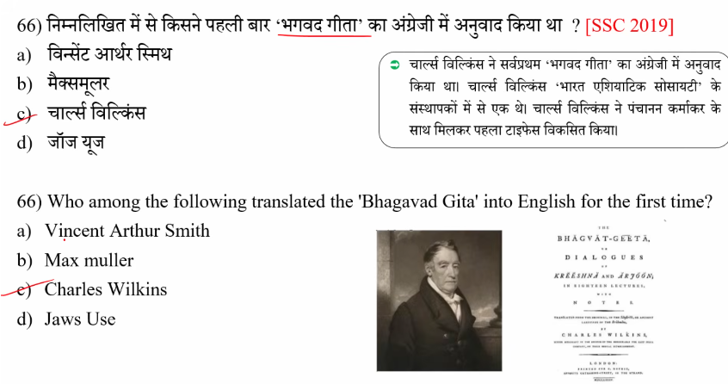
66
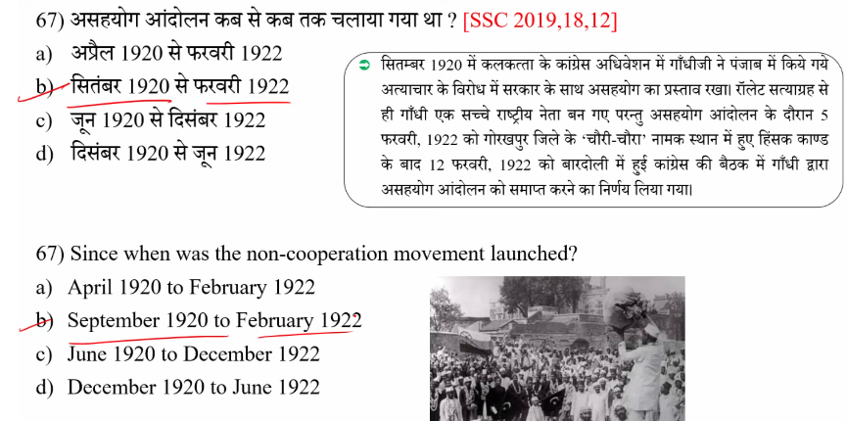

67
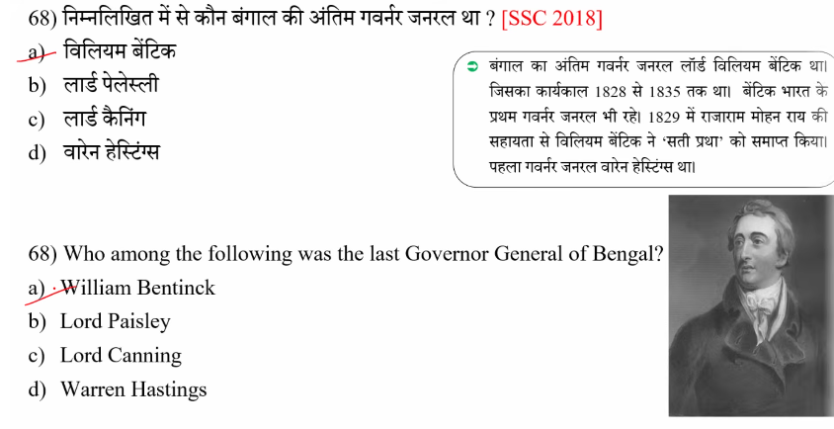

68

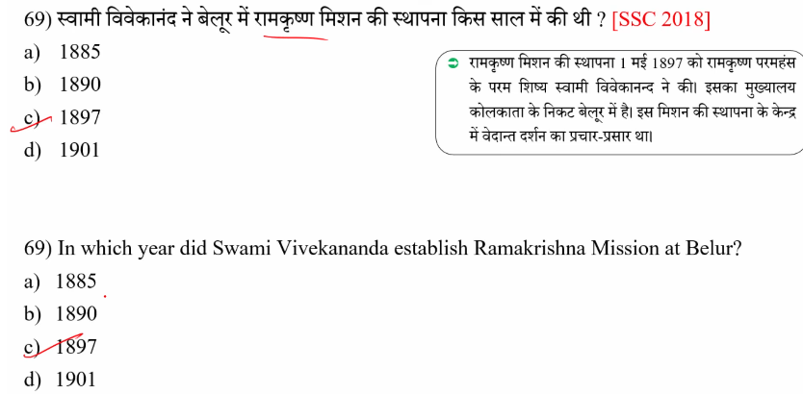

69
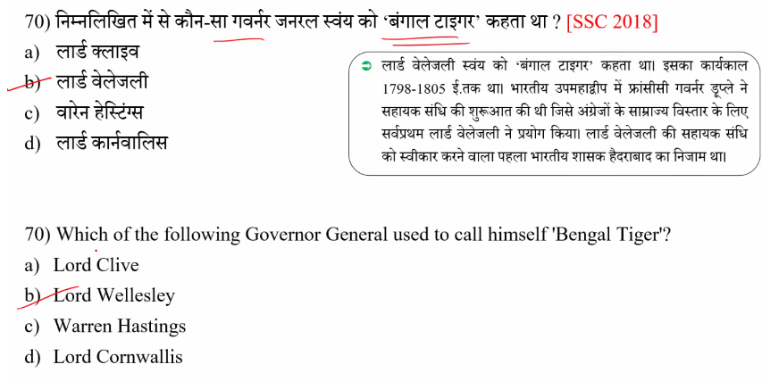

70
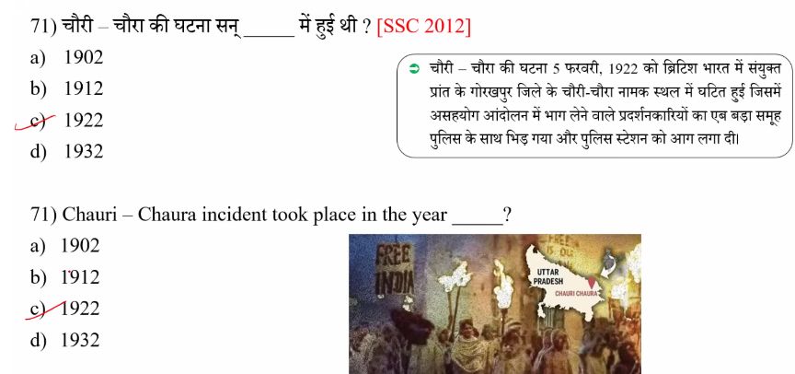

??71
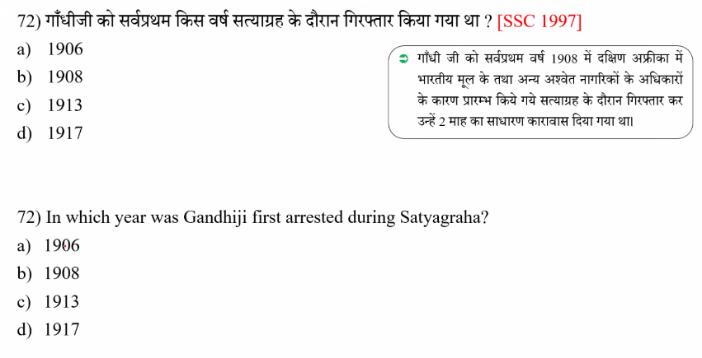

72
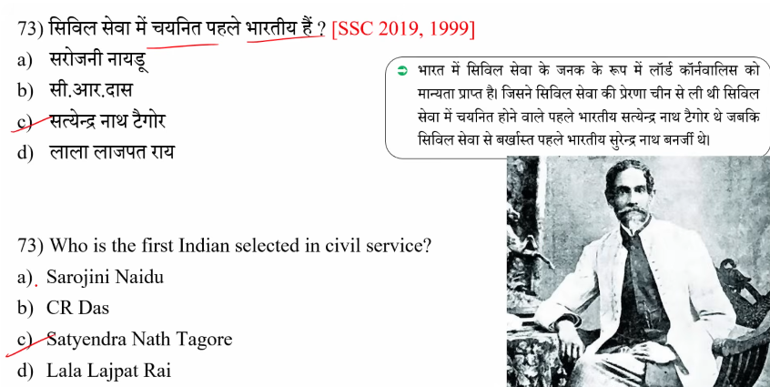

73
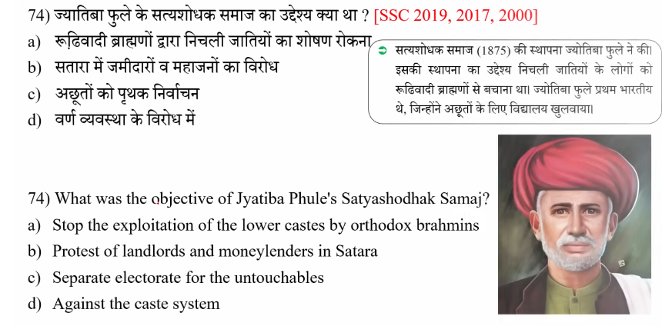

74
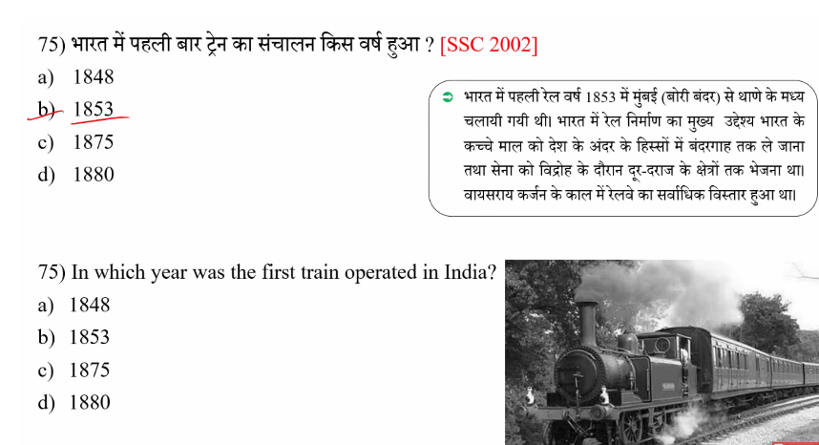

75
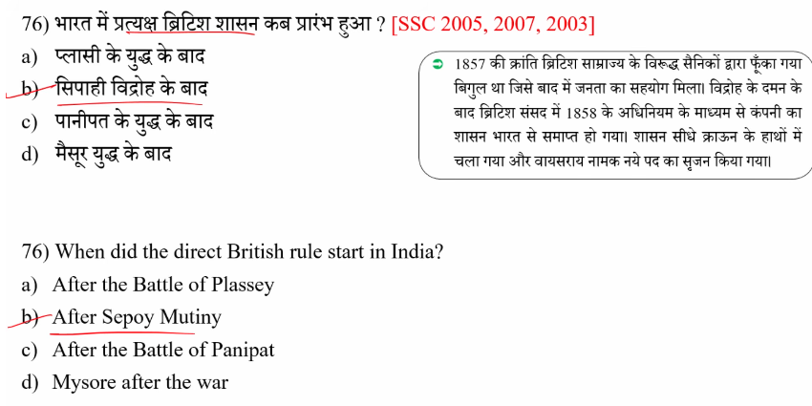

76
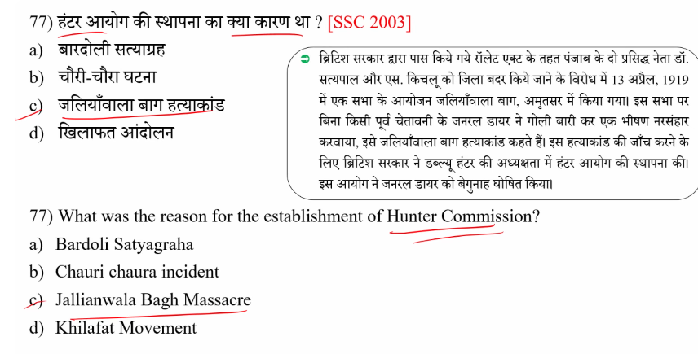

77
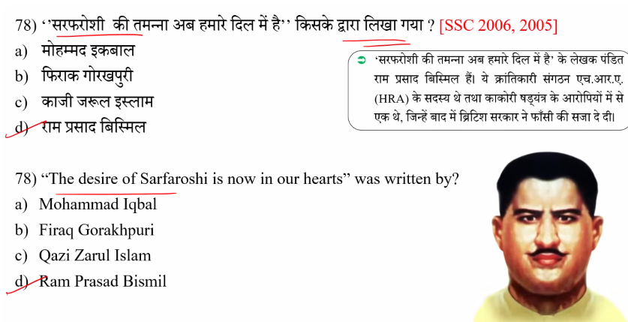
78
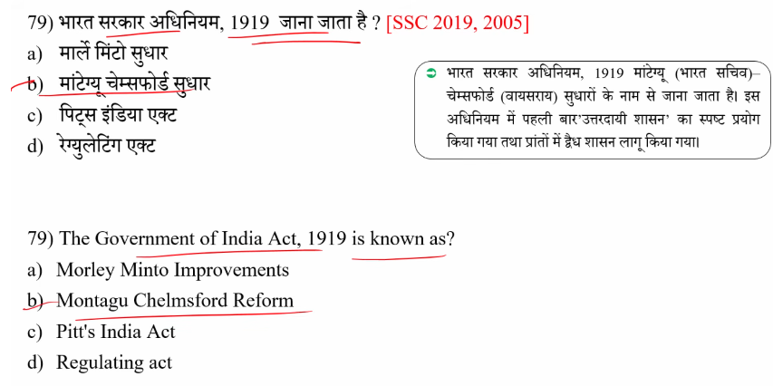
79
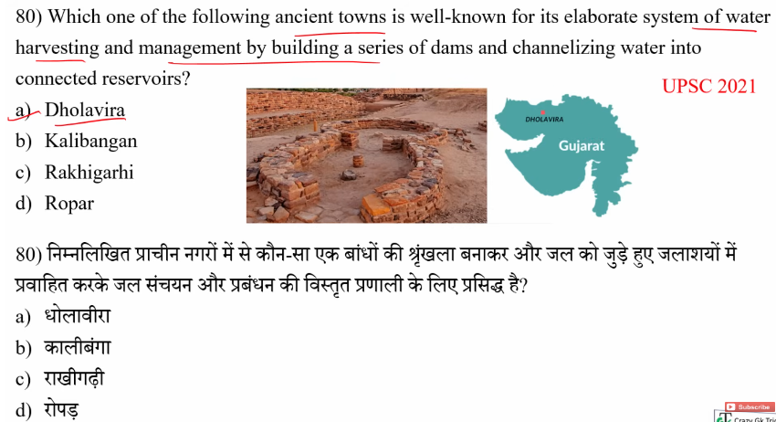

80

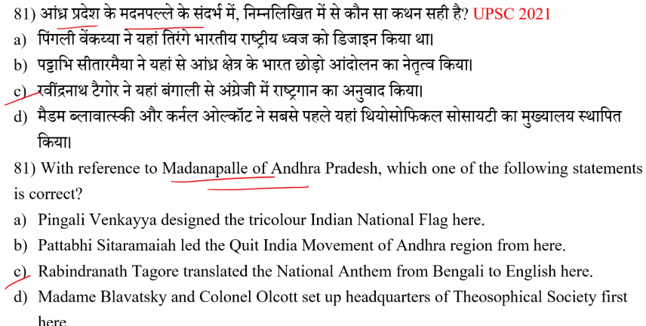

81
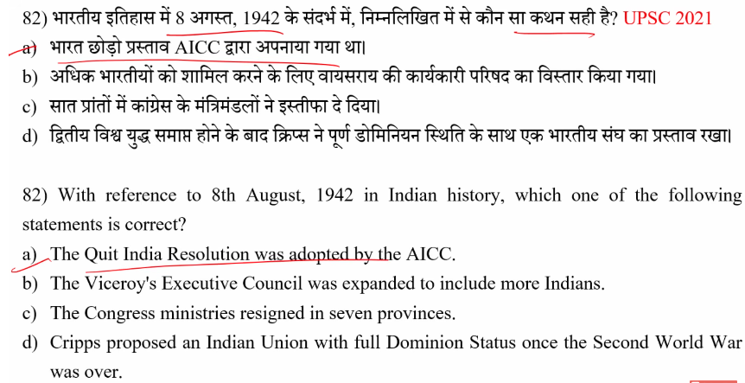

82
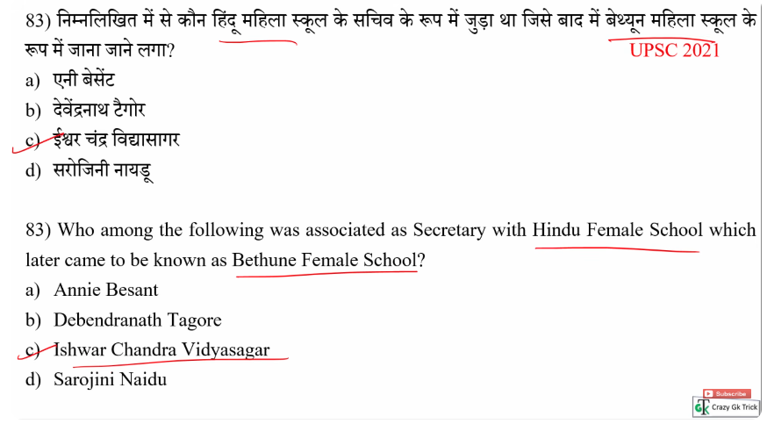

83
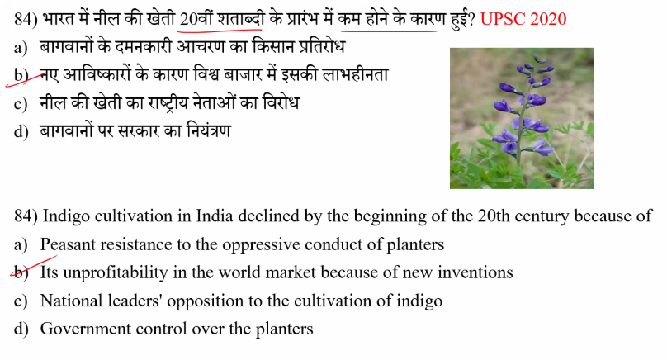

84
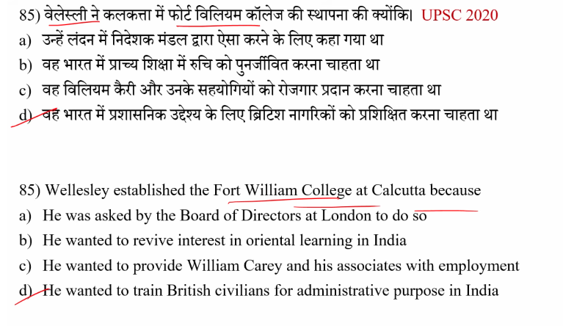

85
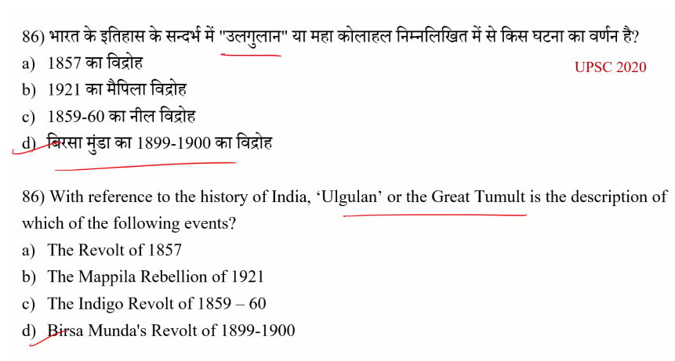
86
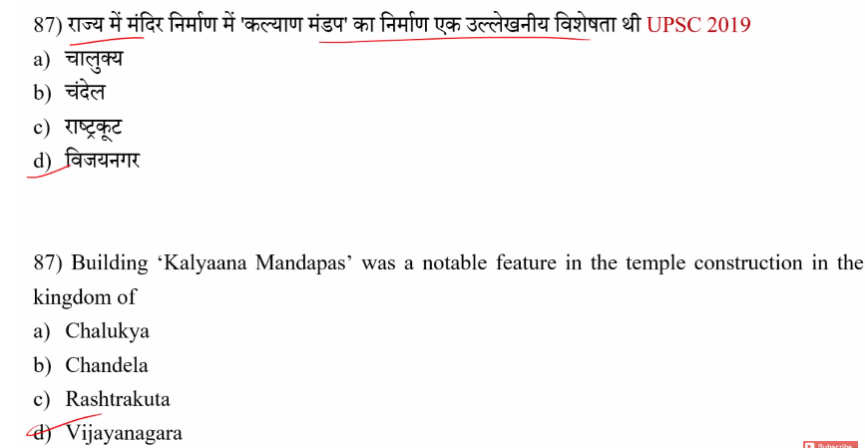

87
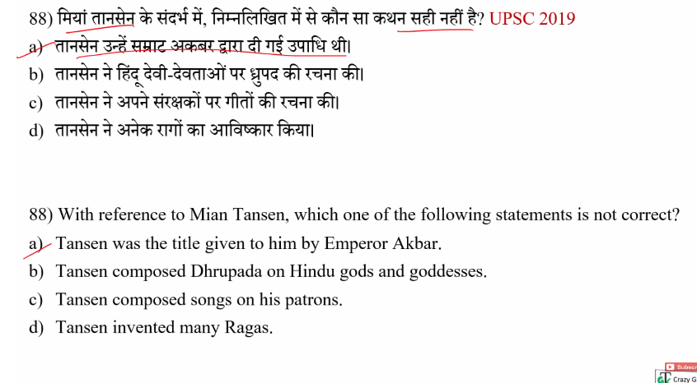
88
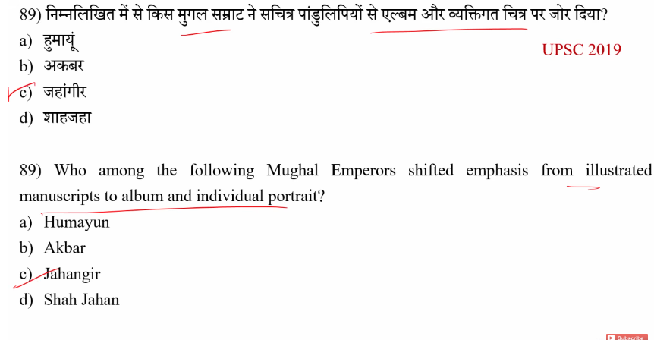

89
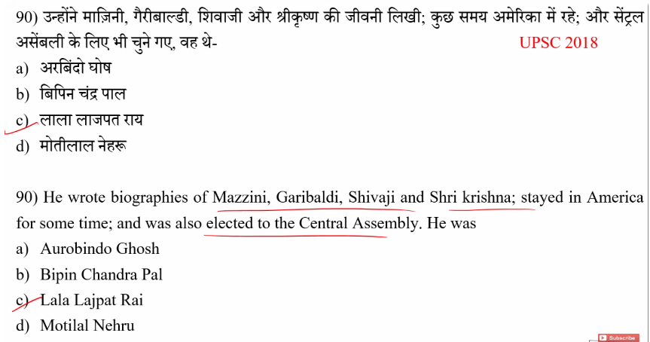
90
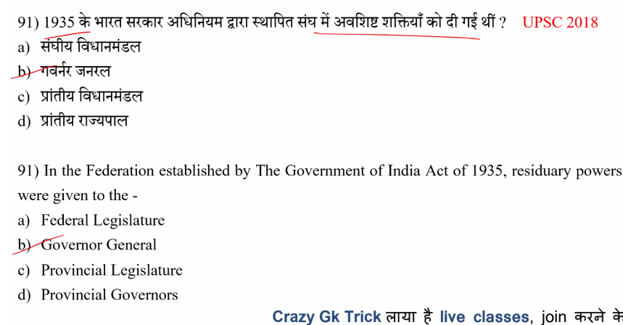1.

91

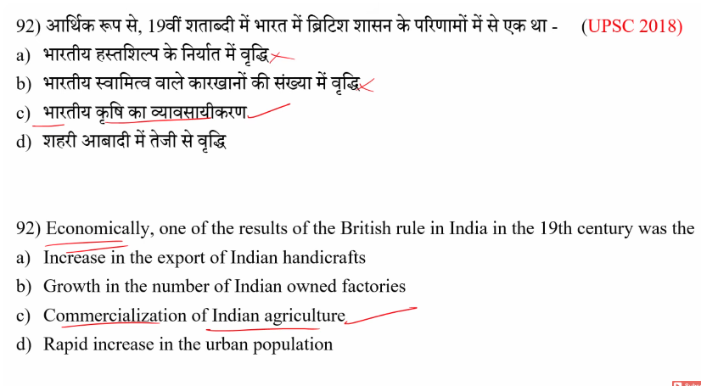\
92

Q. In Vedic philosophy, the concept of duty and obligation towards oneself and others is called:
A. Karma
B. Rta
C. Dharma
D. Moksha
✅ Answer: C. Dharma

93
Q. In Vedic thought, which concept represents the cosmic and moral order of the universe?
A. Dharma
B. Rta
C. Artha
D. Yajna
✅ Answer: B. Rta

94.
Q. Which of the following best describes the concept of Dharma in Vedic civilization?
A. The law of nature
B. The discharge of one’s duties and obligations
C. The cycle of rebirth
D. The worship of gods
✅ Answer: B. The discharge of one’s duties and obligations

📌 प्रश्न:
Vedic civilization में “Dharma” का सही अर्थ क्या है?
✅ सही उत्तर:
👉 B. अपने कर्तव्यों और दायित्वों का पालन करना

🧠 Explanation (सरल हिंदी में)
👉 धर्म (Dharma) का मतलब है:
- सही आचरण करना
- अपने कर्तव्य (duty) और दायित्व (obligation) निभाना
👉 वैदिक काल में यह माना जाता था कि:
- हर व्यक्ति का एक role (भूमिका) होता है
- उसे अपने varna (वर्ण) और ashrama (जीवन के चरण) के अनुसार काम करना चाहिए
➡️ यही धर्म है

❓ “Discharge of one’s duties and obligations” का मतलब
👉 Discharge = पूरा करना / निभाना
👉 पूरा वाक्य का मतलब:
👉 अपने कर्तव्यों और जिम्मेदारियों को सही तरीके से निभाना

📖 आसान उदाहरण
- एक छात्र का धर्म = पढ़ाई करना
- एक राजा का धर्म = प्रजा की रक्षा करना

⚖️ Important Difference
- Rita (ऋत) → प्रकृति का नियम (cosmic law)
- Dharma (धर्म) → इंसान का कर्तव्य (human duty)

❌ बाकी options क्यों गलत हैं?
- A. Law of nature → यह ऋत (Rita) है
- C. Cycle of rebirth → यह संसार / कर्म है
- D. Worship of gods → यह सिर्फ पूजा है, धर्म उससे बड़ा concept है

⚡ One-line (Exam Trick)
👉 Dharma = अपने कर्तव्यों और दायित्वों का पालन 👍

Yes, the worship of gods was central to the Vedic period (c. 1500–500 BCE), but it was profoundly different from modern Hinduism. Early Vedic worship focused on worshipping natural forces (fire, rain, wind) through oral hymns and sacrificial fire rituals (yajna) without idol worship or temples.
The option that best describes the concept of Dharma in Vedic civilization is:
B. The discharge of one’s duties and obligations
Reasoning:
In the Vedic and particularly the Later Vedic period, Dharma evolved to mean the ethical and social duties, obligations, and righteous conduct that an individual must perform based on their varna (class) and ashrama (stage of life). It is a conception of responsibilities that ensures social and personal harmony.
- While Rita (often confused with Dharma) refers to the cosmic, natural law of the universe, Dharma refers to the human application of that order through action.
- It is synonymous with righteousness, duty, and moral law.
Why other options are less appropriate:
- A. The law of nature: This is a better definition of Rita, not Dharma.
- C. The cycle of rebirth: This refers to Samsara or Karma.
- D. The worship of gods: While ritual was part of early Vedic life, Dharma is broader than just ritual worship.
Later Vedic period
Key Details on Dharma in the Later Vedic Period:
- Varna-Ashrama Dharma: Society was divided into four varnas—Brahmins, Kshatriyas, Vaishyas, and Shudras—each with its own distinct duties and roles, known as varna-ashrama dharma.
- Ethical Obligation: It represented a code of conduct for ethical and moral behavior.
- Role-Specific Duties:
  - Brahmanas: Conducting rituals and maintaining social order.
  - Kshatriyas: Ruling and protecting the society.
  - Vaishyas: Engaging in agriculture and commerce.
  - Shudras: Serving the upper three varnas.
- Life Stages (Ashramas): Dharma required adhering to specific duties in each life stage: Brahmacharya (student), Grihastha (householder), and later stages.

95.
Q. Rta in Vedic civilization refers to:
A. Religious rituals
B. Social hierarchy
C. The fundamental law governing the universe
D. Economic activities
✅ Answer: C. The fundamental law governing the universe

96.
Q. The concepts of Dharma and Rta represent the central idea of which civilization?
A. Indus Valley Civilization
B. Mauryan Civilization
C. Vedic Civilization
D. Gupta Civilization
✅ Answer: C. Vedic Civilization

